Focused Meeting – Proposal Form

Please ensure that you read and refer to the guidelines for submitting a Focused Meeting proposal and ensure all questions are answered fully.

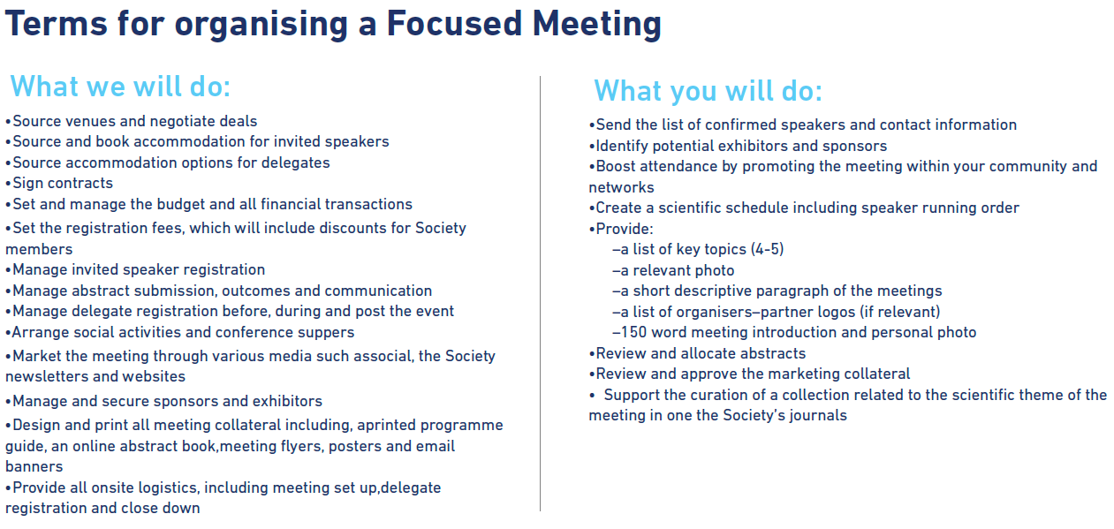

Accepted Focused Meetings will receive full secretariat support from the Society as detailed above.
Organisers are required to discuss their proposal prior to submission, with a member of the relevant Division(s). Organisers are requested to keep in mind the upcoming deadline for submission as advised online.
Further questions on completion of this form should be addressed to the conference office.
Email: conferences@microbiologysociety.org Tel. +44 (0) 20 3034 2684

Q1: APPLICANT DETAILS
Membership Number
First Name |  | Surname
Organisation/Affiliation
Contact Address
Telephone Number |  | Email

Q2: DIVISIONS
Before submission, all applicants are required to contact a relevant Division Member as listed below to seek their advice and support for the proposal. Applications not discussed with Division(s) are more likely to be returned for revision or declined.
Division | Division Contacted | Position | Name | Contact
Eukaryotic |  | Chair | Anastasios Tsaousis | a.tsaousis@kent.ac.uk
Eukaryotic |  | C/Elect | Alison Smith | as25@cam.ac.uk
Prokaryotic |  | Chair | Martin Welch | mw240@cam.ac.uk
Prokaryotic |  | C/Elect | Christopher Cooper | c.d.cooper@hud.ac.uk
Virus |  | Chair | Jo Parish | J.L.Parish@bham.ac.uk
Virus |  | C/Elect | Matthew Reeves | matthew.reeves@ucl.ac.uk
Irish |  | Chair | Gerald Barry | Gerald.barry@ucd.ie
Irish |  | C/Elect | Jerry Reen | J.Reen@ucc.ie

Q3: SESSION ORGANISERS
Please list those who will be involved in organising this Meeting, including identifying speakers, planning out the scientific content, approving abstracts and promoting the session within their institutes. (Minimum 2/Maximum 4)
Organisers | Membership number | First Name | Surname | Affiliation | Email Address
*Lead Organiser
2
3
4
*The lead organiser will be the main point of contact with the Society

Q4: PROPOSED TITLE OF MEETING
Please provide the full working title of the meeting.
Q5: SCIENTIFIC OR EDUCATIONAL CASE FOR THE MEETING
This should contain a summary and rationale for the meeting. It should suggest why the topic is timely and what the intended audience will gain from attending (400–500 words).

Q6: LENGTH OF MEETING
Please indicate the length of the proposed meeting in days.

Q7: PROPOSED DATE FOR THE MEETING
Organisers are asked to propose a date for the meeting. This should not clash with other events on a similar topic being held in the UK or globally. A list of microbiological meetings can be found on the Society’s website (Events | Microbiology Society). Please note that this list should not be considered fully comprehensive and organisers are asked to carry out additional research as appropriate.

Dates suggested by the meeting organisers are not necessarily guaranteed once a meeting proposal has been accepted. The meeting dates will be determined after consideration of other events and key dates in the Society’s annual programme, while taking into account availability of the conference and events team’s resources.

Q8: RECENT, COMPETING OR FUTURE MEETINGS
The financial viability of our meetings is dependent on attendance. This can be undermined by the occurrence of related recent, competing or future meetings in the field. Organisers are therefore requested to apply due diligence in order to research and confirm the details of other meetings that might potentially compete for delegates in the suggested field.
Name of Meeting | Date | Location

Q9: Event format
The Society is able to run select Focused Meetings as online events instead of physical meetings, where an online event would better suit a particular community.

Please indicate your preferred format for the meeting below.

In person
Virtual
Hybrid please contact the Society’s conferences team at conferences@microbiologysociety.org before submitting your application if your preference is to make any elements of the meeting available to both an in-person and online audience. Any requests to run a meeting for both an in-person and online audience will be reviewed in consideration of the anticipated audience size, event programme and the technical provisions and facilities available at a preferred venue.

Q10: VENUE
If your preference is to run an in-person meeting, please list any suggested locations or venues. Please note it is essential to consult with the Conferences and Events Team BEFORE committing to any venue to ensure value for money, suitability of location and facilities within the venue.
Venue Name or Location | Address | URL

Q11: ANTICIPATED AUDIENCE, DESCRIPTION AND SIZE
Please indicate the approximate total number of delegates you anticipate the meeting will attract.
Make up of Audience  (ratio of postgrad/students to non-students) | Anticipated Total Delegates  (exclude speakers, organisers and staff)

Q12: RELATED SCIENTIFIC GROUPS
Please provide details of any research groups or other scientific groups that might be interested in attending the meeting. Please include details of organisations that are based in UK or Ireland, or the host country if the meeting is to be held outside of the UK and Ireland.
Group Name | Group details (including geographical location, estimated number of members etc)

Q13: MEETING PROGRAMME
Organisers are asked to provide an outline of the draft programme including potential speakers, affiliations and talk titles.

Please also indicate here the time given in the programme for delegate interaction, including but not limited to, panel discussions, flash poster presentations and offered orals.

Please be aware that invited speakers must present for at least 30 minutes and should not exceed the Society’s Invited Speaker Geographical Guidelines. The maximum number of speakers per half day is 4. It is up to the meeting organisers how long the invited speakers will speak for; a longer key note talk may be preferred.

In terms of geographical location, allowances per half day are:
- Europe/Ireland/UK = minimum of 1 invited speaker
- USA/Canada = maximum of 1 invited speaker
- Rest of the world = maximum of 1 invited speaker

For in-person meetings, travel allowances will be paid in line with the Society’s stated Travel Allowances (see Terms and Conditions on the Society website) for invited speakers and organisers.

Day | Time (00:00) | Session  (include suggested title/topic, speaker name and affiliation – as detailed in the example) | Gender  (M/F) | Location  (UK/  Europe/  RoW)
Day one | 09:00 | EBV-induced aberrant cell signalling as a potential anti-cancer target, Sophie Brown (University of East Sussex, UK) | F | UK
 | 09:30 | Offered Oral | TBC
Day two | 09:00 | Suppression of Virus-induced Necroptosis by Herpesviruses and Poxviruses, Ed Mocarski (Emory University School of Medicine, USA) | M | USA
Please add additional rows if required.

Q14: GENDER DIVERSITY
As our data shows that 53% of our members are women, 45% are men and 1% are non-binary, it is a requirement that fair gender representation and inclusion is achieved in the composition of the meeting programme, in order for the proposal to be reviewed. Please provide a brief statement detailing how you have considered addressing this with in your identified speakers. In order to inform you of the wider composition of the community, we have also provided data on the proportion of the membership which identifies as from a minority ethnic group, and those who disclose a known disability or impairment. This data can be found on the Society’s website (https://microbiologysociety.org/why-microbiology-matters/equality-diversity.html).

Q15: ADDITIONAL FUNDING/SPONSORSHIP
Please indicate if funding or sponsorship has or is being sought from other Societies, Institutions or sponsors in Great British Pounds (GBP).
Name of Funder | Description of Support | Amount | Secured (Y/N)

Q16: JOINT WORKING
Would this meeting benefit from being held jointly with another organisation? Please indicate which organisations might be appropriate to joint fund or promote the meeting, if you have already approached them and the interest expressed.
Name of organisation  or company | Approach Made (Y/N) | Interest Expressed (Y/N)

Q17: PUBLISHING
The Microbiology Society is a not-for-profit publisher, and we publish high-quality research papers and topical review articles. Please select the most appropriate journal(s) for your proposed Focused Meeting content. We will then look for opportunities to use our publishing and editorial networks to support you in delivering a successful meeting for your community and to identify potential publishing outputs through the journals.
Further information can be found at Our journals | Microbiology Society
Microbiology
Journal of General Virology
Journal of Medical Microbiology
Access Microbiology
Microbial Genomics
International Journal of Systematic and Evolutionary Microbiology

Q18: APPLICATION DECLARATION
All Focused Meetings are underwritten by the Microbiology Society, and it is a requirement that discounted event rates will be made available for our members, as standard.
Please be advised that if your proposal if accepted, the Society will retain full responsibility for setting delegate registration fees and managing the meeting budget.

I have read and agree with the preceding statements and agree to all of the terms and conditions as outlined by the Society at the start of this document.
Name | Signature | Date

Completed proposal forms should be sent to conferences@microbiologysociety.org by the deadline as displayed online.

